**Case Study 1**

**Maven Application Project Generated by using Spring Initializer**

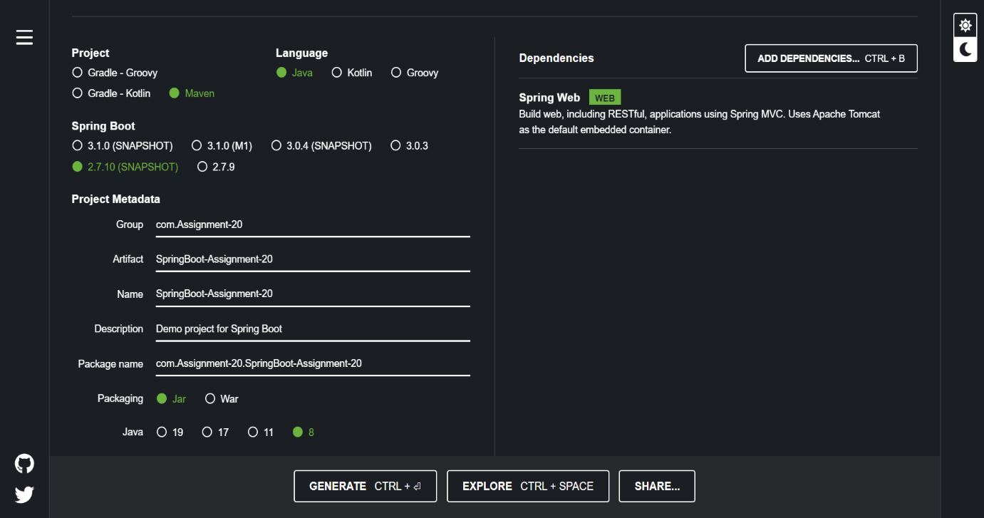

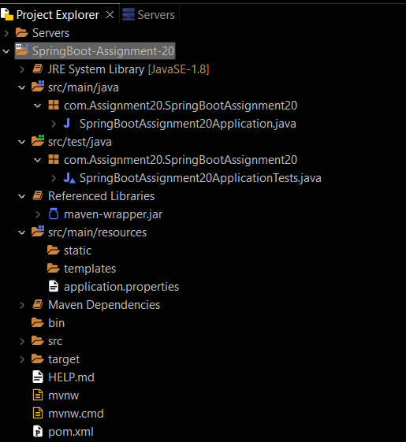

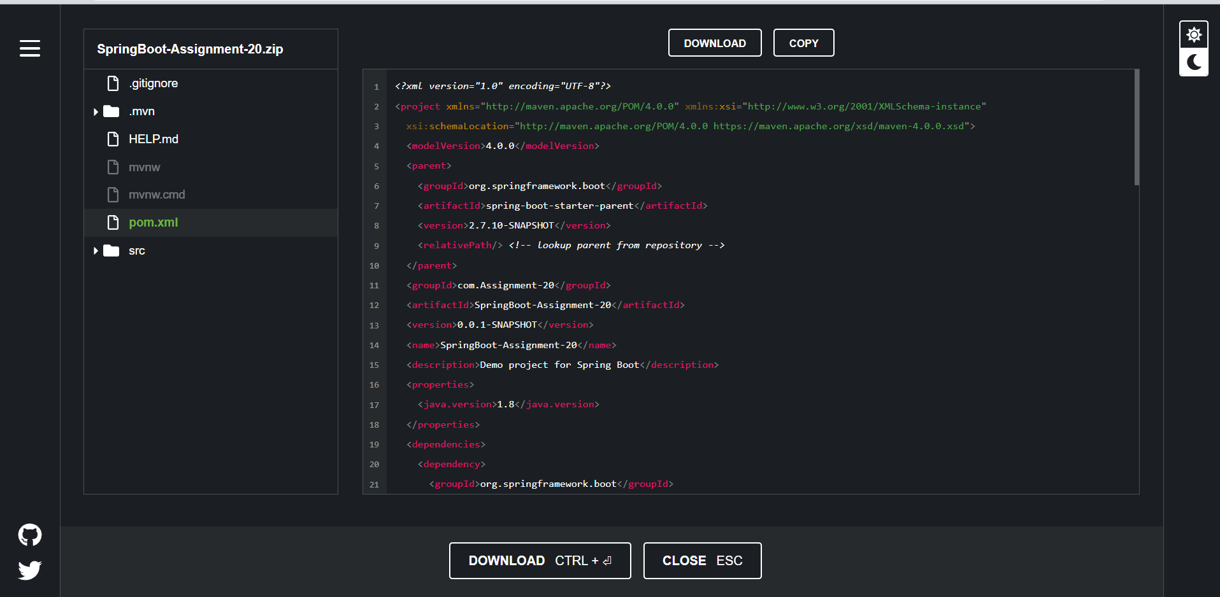

**Case Study 2**

**package com.Assignment20.SpringBootAssignment20;**

**import org.springframework.boot.SpringApplication;**

**import org.springframework.boot.autoconfigure.SpringBootApplication;**

**import org.springframework.context.annotation.ComponentScan;**

**@SpringBootApplication**

**@ComponentScan({"com.springboot.contoller"})**

**public class SpringBootAssignment20Application {**

**public static void main(String[] args) {**

**SpringApplication.run(SpringBootAssignment20Application.class, args);**

**}**

**}**

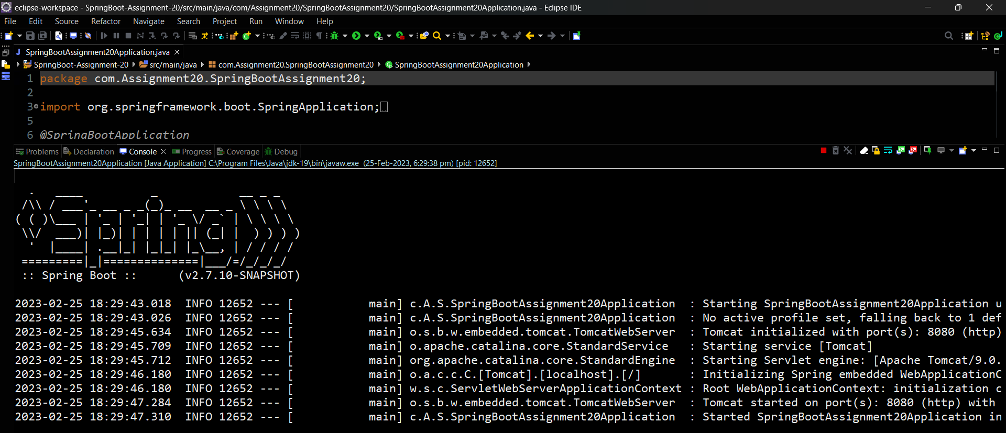

**Case Study 3**

// RajController.java

package com.springboot.contoller;

import org.springframework.web.bind.annotation.RequestMapping;

import org.springframework.web.bind.annotation.RestController;

*@RestController*

public class RajController {

*@RequestMapping*("/")

public String show() {

return "Hi! My name is Raj Ganesh, but you can call me Raj. ";

}

}

**// SpringBootAssignment20Application.java**

**package com.Assignment20.SpringBootAssignment20;**

**import org.springframework.boot.SpringApplication;**

**import org.springframework.boot.autoconfigure.SpringBootApplication;**

**import org.springframework.context.annotation.ComponentScan;**

**@SpringBootApplication**

**@ComponentScan({"com.springboot.contoller"})**

**public class SpringBootAssignment20Application {**

**public static void main(String[] args) {**

**SpringApplication.run(SpringBootAssignment20Application.class, args);**

**}**

**}**

**Output:**

